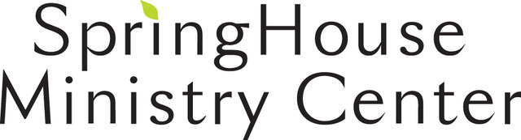
SPRINGHOUSE LIBRARY DONATION POLICY
Approved 12/17/2014 (updated 1/30/2024)

SpringHouse Library will gratefully accept book and nonbook materials that:
- help fulfill the mission of the individual churches and/ or SpringHouse
- are in good condition
- reflect current thinking, questioning, discussion (exception-classic works)
- accurately teach about faith and belief in a balanced way
- expand the offerings in the various categories of materials listed below:
The SpringHouse Library is designed to support the missions of SpringHouse, Lyndale United Church of Christ, First Christian and Salem Lutheran Churches. With that goal, SpringHouse Library will include the following types of materials.

1. Inspirational and Devotional books and media
2. Reference Materials; for example, Bible concordances, dictionaries, atlases, commentaries, handbooks, Bible history, Bible biography, and church history
3. Theological works; for example, discussions of Christian faith, God, Jesus Christ, the Holy Spirit, and salvation
4. Specific denominational resources; for example, creeds, theology, working papers of specific denominations, denominational history
5.Materials for special SpringHouse groups; for example, Christian fiction, inspirational biographies and autobiographies, music large print or audio books
6. Materials addressing various topics, for example: world religions; worship; religious art; hymnology and liturgies; symbolism; church drama; Christian family life; Christian education; missions; marriage and family life; social concerns; missionary and evangelistic work; individual needs related to death, care giving, divorce, etc; church management; health and wellness, environmental stewardship; other special ministries
Donations of new or used materials are accepted with the understanding that the library staff (committee) may use discretion in the placement of the materials. Items that cannot be used will be returned to the donor if she or he wishes or disposed of in an appropriate manner.

