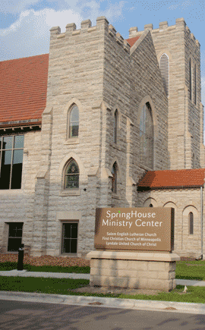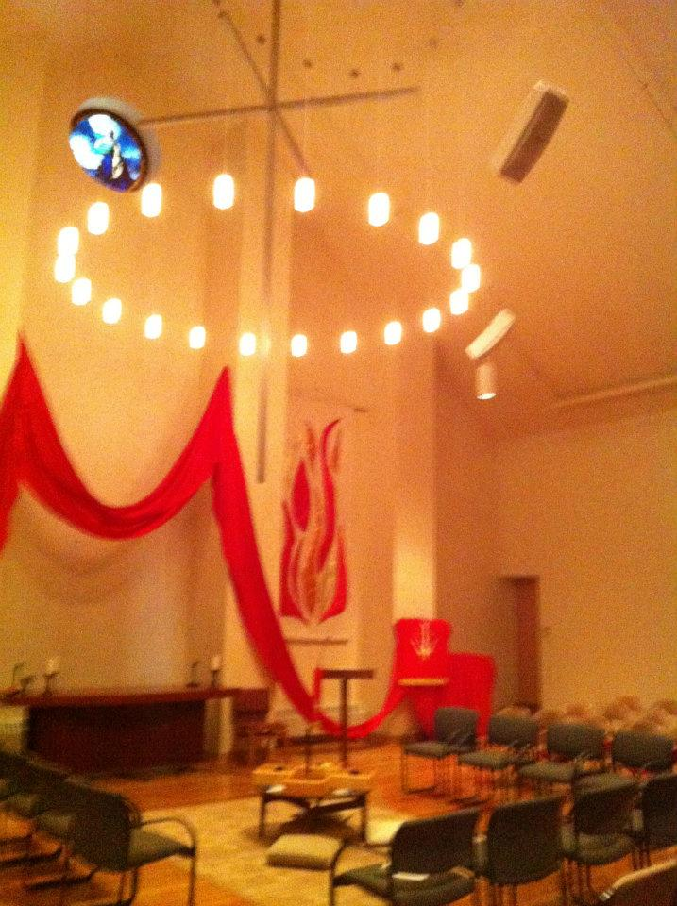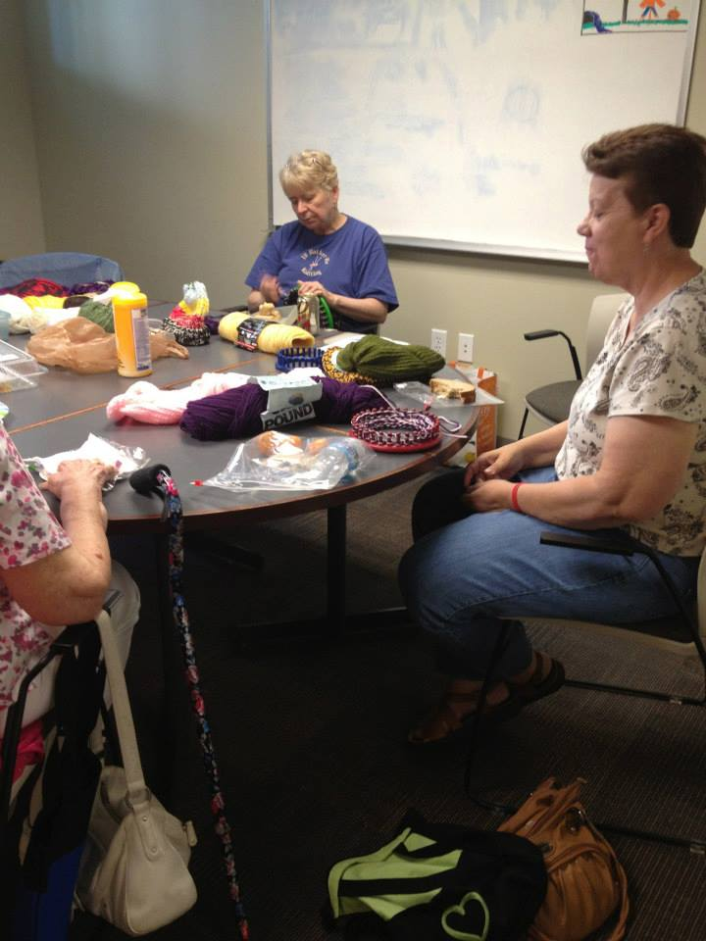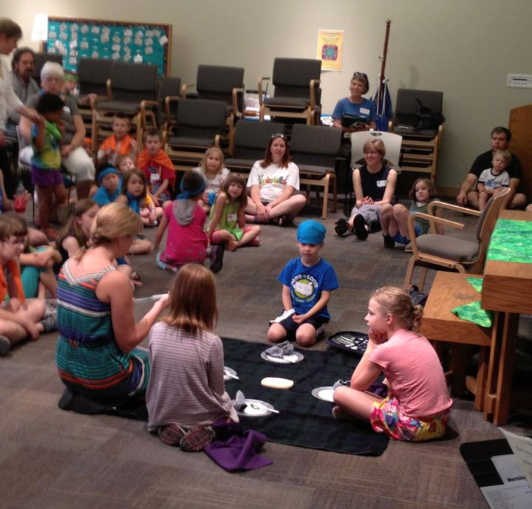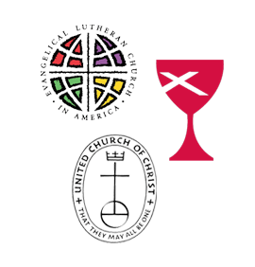

SpringHouse is a new way to be church in the 21st Century. It is a way in which congregations can become more environmentally and financially stable, allowing them to be free to do God’s mission in new ways.

SpringHouse is also a space where people can worship and learn about God. It is a place where the wider community can meet, renew, grow and work for wholeness.

SpringHouse is used on an onging basis by a variety of groups in the community – yoga classes, poetry classes, theaters, choral groups, LGBTQA teens, Narcotics Anonymous, dance groups, concerts …the list is practically infinite. Other groups use space for a one-time meeting or an all-day retreat.

*Need a space for your club or group?*

*Call us!*

*First Christian Church (Disciples of Christ)*

*Lyndale United Church of Christ*

*Salem English Lutheran Church*

### A New Way To Be Church

SpringHouse Ministry Center

610 W. 28th St.

Minneapolis, MN, 55408

[www.springhousemc.org](http://www.springhousemc.org) 612-353-6292

610 W. 28th St.

Minneapolis, MN. 55408

612-353-6292

www.springhousemc.org

* Three Churches…
* …One Spirit!

***Lyndale United Church of Christ:***Pastor Don Portwood [www.lyndaleucc.org](http://www.lyndaleucc.org" \t "_blank) 612-825-3019

Lyndale’s 120 members are committed to being a spiritual/activist community. We’ve been around the LynLake corner since 1884. We invite you to join us in some of the ways we’re trying to make our neighborhood, city and world a healthier place. We’re a small and spirited community, and no matter who you are on your journey, you’ll be welcomed here.

***Salem English Lutheran* Church:** Pastor Jen Nagel [www.discoversalem.org](http://www.discoversalem.org" \t "_blank) 612-872-4650

"Salem is a Spirit-led, welcoming, and bold Christian community rooted in the neighborhood, striving to live faithfully in God's world."  Salem English Lutheran began back in 1890 as one of the first if its kind of Lutheran church to worship in the English language (rather than Norwegian or Swedish or German).  From its start, Salem was a congregation of diverse backgrounds.

To this day, Salem seeks to speak the "language" of the neighborhood, offering an authentic way to be Christian and faithful in the Lutheran tradition.  Salem is part of the Evangelical Lutheran Church in America (ELCA) and is a Reconciling in Christ (RIC) congregation welcoming the leadership and participation of all people including the LGBTQ community.  We use two primary worship styles, Jazz and Traditional, share Holy Communion weekly, and offer opportunities for justice, advocacy, worship, education and fellowship for all ages-little ones, young adults, elders, and everyone in between.

*Come Visit Us!*

Sunday Morning Schedule

8:30 am – Salem Traditional Service

9 am – First Christian Adult Education

9:15 am – Lyndale Adult Education

Children’s Sunday School

9:40 am – Salem Adult Ed

10:30 am – Worship

Salem Jazz Service

Lyndale Worship

First Christian Worship

*(ask greeter for the sanctuary of your congregation of choice)*

11:30 am – Fellowship Time in the Gathering Space

*Other On-Going Activities*

2nd/4th Mondays, 9:30 am: Play Group for children up to 4 yrs old and their care provider.

Wednesdays, 8:30 am: Bible Study

Thursdays, 9 am: Knitting Group

Saturdays, 9 am: Men’s Bible Study

Check the churches’ websites for short-term studies and other events:

[www.fccmpls.org](http://www.fccmpls.org)

[www.lyndaleucc.org](http://www.lyndaleucc.org)

[www.discoversalem.org](http://www.discoversalem.org)

Each congregation worships in its own way in one of three worship spaces. Together we share common ministries and mission.

SpringHouse Ministry Center is comprised of three separate congregations from three different denominations — each one unique, yet with much in common.

***First Christian Church, Minneapolis (Disciples of*** ***Christ):***Pastor Laurie Feille

[www.fccmpls.org](http://www.fccmpls.org" \t "_blank) 612-870-1868

Since 1877, First Christian has been a living witness of Jesus Christ in South Minneapolis.    On a Sunday morning, you will see young and old, rich and poor, gay and straight coming together to worship God.  You will hear music from various traditions, the word of God preached, and your prayers will be heard by God and the church community.

We are an open and affirming congregation, engaged in our community, supporting ministries like [Downtown Congregations to End Homelessness](http://www.dceh.org/), [Groveland Foodshelf](http://www.grovelandfoodshelf.org/), [Feed My Starving Children](http://www.fmsc.org/), [Community Emergency Service](http://www.cesmn.org/), the [Aliveness Project](http://www.aliveness.org/) and much more.  We believe in getting involved actively in mission projects and bringing the love of Jesus in acts of justice here in the Twin Cities and around the world.

# Who We Are

#### Sed consequat.

Sed sagittis, augue eu varius pretium, tortor nibh tincidunt enim, at consectetuer urna velit non pede. Curabitur pulvinar, dui et porta egestas, nisl neque bibendum nunc, quis iaculis ligula lectus ut sem. Etiam pellentesque, nibh nec accumsan ultrices, mauris quam eleifend nunc, a elementum eros neque lacinia massa. Ut iaculis. Etiam id nisl quis tellus rhoncus tempor. Nulla nulla. Maecenas in tellus et neque fermentum condimentum. Ut aliquet diam. Vestibulum auctor pede eget quam. Morbi elementum consequat nulla. Fusce malesuada, dui condimentum vestibulum tincidunt, neque mauris posuere turpis, in lacinia quam odio vitae leo.

#### Maecenas tortor.

Proin at libero in erat pharetra pellentesque. Class aptent taciti sociosqu ad litora torquent per conubia nostra, per inceptos hymenaeos. Cum sociis natoque penatibus et magnis dis parturient montes, nascetur ridiculus mus. In hac habitasse platea dictumst. Donec sit amet elit id orci commodo pharetra. Vivamus iaculis dui vel elit. Quisque ut lectus sed diam volutpat ultrices. Vestibulum ante ipsum primis in faucibus orci luctus et ultrices posuere cubilia Curae; Phasellus bibendum massa at mauris commodo fermentum. Phasellus odio. Duis lacus nisi, blandit sit amet, rutrum id, porta eu, est. Vivamus sollicitudin. Nunc aliquet ipsum eget arcu. Nam pulvinar massa sed ante. Fusce augue justo, commodo nec, consequat id, pharetra vel, nisl. Nullam et elit. Mauris bibendum libero sit amet urna semper fermentum. Sed ac tellus vitae ante facilisis dapibus.

#### Proin id mi.

Maecenas nisl elit, auctor vel, venenatis quis, consectetuer sit amet, nibh. Ut laoreet elementum nisl. Vestibulum dapibus blandit tellus. Vivamus facilisis dignissim lacus. Aliquam commodo nibh. Nunc posuere vulputate nisl. Praesent et nibh nec enim varius eleifend. Aliquam vel mi eget ipsum scelerisque adipiscing. Maecenas enim odio, mollis vitae, consequat et, aliquam eget, est. Donec elit metus, molestie sollicitudin, condimentum eu, elementum vel, neque. Morbi eu purus eu metus porta dignissim. Cras auctor dictum arcu. Nullam pulvinar, ligula ac rhoncus fringilla, risus elit fringilla velit, nec ullamcorper quam tellus ac lacus.

Quisque scelerisque convallis ligula. In cursus semper mi. Mauris quis magna. Morbi molestie, quam eget scelerisque ultrices, risus orci vestibulum quam, ac ullamcorper augue eros at urna. Sed nonummy mollis tellus.

#### Nullam et massa.

Sed pharetra fermentum massa. Class aptent taciti sociosqu ad litora torquent per conubia nostra, per inceptos hymenaeos. Vestibulum fermentum feugiat quam. Integer neque turpis, ultrices at, semper nec, molestie quis, est. Vestibulum nec enim. Nullam orci. Cras hendrerit**Meet the Partners**

***First Christian Church, Minneapolis (Disciples of*** ***Christ):***Pastor Laurie Feille                    [www.fccmpls.org](http://www.fccmpls.org" \t "_blank)

Since 1877, First Christian has been a living witness of Jesus Christ in South Minneapolis.    On a Sunday morning, you will see young and old, rich and poor, gay and straight coming together to worship God.  You will hear music from various traditions, the word of God preached, and your prayers will be heard by God and the church community.

We might be small in number, but we are mighty in impact.  We are engaged in our community, supporting ministries like [Downtown Congregations to End Homelessness](http://www.dceh.org/), [Groveland Foodshelf](http://www.grovelandfoodshelf.org/), [Feed My Starving Children](http://www.fmsc.org/), [Community Emergency Service](http://www.cesmn.org/), the [Aliveness Project](http://www.aliveness.org/) and much more.  We believe in getting involved actively in mission projects and bringing the love of Jesus in acts of justice here in the Twin Cities and around the world.

***Salem English Lutheran* Church:** Pastor Jen Nagel [www.discoversalem.org](http://www.discoversalem.org" \t "_blank)

Salem English Lutheran was one of the first Lutheran congregations of its kind west of Chicago to worship in the English language. While other Lutheran congregations were deeply tied to specific ethnic backgrounds and languages (such as Norwegian, German, Swedish, and Danish), from its start Salem was a congregation of diverse backgrounds. This diversity and a desire to worship in the language of the neighborhood is still part of Salem’s calling. As the neighborhood has evolved, Salem strives to speak the “language” of our area and offer an authentic way of being Christian.

The Salem congregation began in 1890.  By 1904, parts of the current facility were built with significant additions added every few decades. Most recently, of course, was the renovation that created the SpringHouse Ministry Center. Prior to the [Evangelical Lutheran Church in America](http://www.elca.org/" \o "Evangelical Lutheran Church in America" \t "_blank)(ELCA), Salem was part of the Lutheran Church in America.

SpringHouse Ministry Center is comprised of three church partners: three separate congregations from three different denominations — each one unique, yet with much in common.

**Meet the Partners**

***First Christian Church, Minneapolis (Disciples of*** ***Christ):***Pastor Laurie Feille                    [www.fccmpls.org](http://www.fccmpls.org" \t "_blank)

Since 1877, First Christian has been a living witness of Jesus Christ in South Minneapolis.    On a Sunday morning, you will see young and old, rich and poor, gay and straight coming together to worship God.  You will hear music from various traditions, the word of God preached, and your prayers will be heard by God and the church community.

We might be small in number, but we are mighty in impact.  We are engaged in our community, supporting ministries like [Downtown Congregations to End Homelessness](http://www.dceh.org/), [Groveland Foodshelf](http://www.grovelandfoodshelf.org/), [Feed My Starving Children](http://www.fmsc.org/), [Community Emergency Service](http://www.cesmn.org/), the [Aliveness Project](http://www.aliveness.org/) and much more.  We believe in getting involved actively in mission projects and bringing the love of Jesus in acts of justice here in the Twin Cities and around the world.

***Salem English Lutheran* Church:** Pastor Jen Nagel [www.discoversalem.org](http://www.discoversalem.org" \t "_blank)

Salem English Lutheran was one of the first Lutheran congregations of its kind west of Chicago to worship in the English language. While other Lutheran congregations were deeply tied to specific ethnic backgrounds and languages (such as Norwegian, German, Swedish, and Danish), from its start Salem was a congregation of diverse backgrounds. This diversity and a desire to worship in the language of the neighborhood is still part of Salem’s calling. As the neighborhood has evolved, Salem strives to speak the “language” of our area and offer an authentic way of being Christian.

The Salem congregation began in 1890.  By 1904, parts of the current facility were built with significant additions added every few decades. Most recently, of course, was the renovation that created the SpringHouse Ministry Center. Prior to the [Evangelical Lutheran Church in America](http://www.elca.org/" \o "Evangelical Lutheran Church in America" \t "_blank)(ELCA), Salem was part of the Lutheran Church in America.

***Lyndale United Church of Christ:***Pastor Don Portwood [www.lyndaleucc.org](http://www.lyndaleucc.org" \t "_blank)

Lyndale’s 120 members are committed to being a spiritual/activist community. We’ve been around the LynLake corner since 1884. We invite you to join us in some of the ways we’re trying to make our neighborhood, city and world a healthier place. We’re a small and spirited community, and no matter who you are on your journey, you’ll be welcomed here.

SpringHouse Ministry Center is comprised of three church partners: three separate congregations from three different denominations — each one unique, yet with much in common.

**Meet the Partners**

***First Christian Church, Minneapolis (Disciples of*** ***Christ):***Pastor Laurie Feille                    [www.fccmpls.org](http://www.fccmpls.org" \t "_blank)

Since 1877, First Christian has been a living witness of Jesus Christ in South Minneapolis.    On a Sunday morning, you will see young and old, rich and poor, gay and straight coming together to worship God.  You will hear music from various traditions, the word of God preached, and your prayers will be heard by God and the church community.

We might be small in number, but we are mighty in impact.  We are engaged in our community, supporting ministries like [Downtown Congregations to End Homelessness](http://www.dceh.org/), [Groveland Foodshelf](http://www.grovelandfoodshelf.org/), [Feed My Starving Children](http://www.fmsc.org/), [Community Emergency Service](http://www.cesmn.org/), the [Aliveness Project](http://www.aliveness.org/) and much more.  We believe in getting involved actively in mission projects and bringing the love of Jesus in acts of justice here in the Twin Cities and around the world.

***Salem English Lutheran* Church:** Pastor Jen Nagel [www.discoversalem.org](http://www.discoversalem.org" \t "_blank)

Salem English Lutheran was one of the first Lutheran congregations of its kind west of Chicago to worship in the English language. While other Lutheran congregations were deeply tied to specific ethnic backgrounds and languages (such as Norwegian, German, Swedish, and Danish), from its start Salem was a congregation of diverse backgrounds. This diversity and a desire to worship in the language of the neighborhood is still part of Salem’s calling. As the neighborhood has evolved, Salem strives to speak the “language” of our area and offer an authentic way of being Christian.

The Salem congregation began in 1890.  By 1904, parts of the current facility were built with significant additions added every few decades. Most recently, of course, was the renovation that created the SpringHouse Ministry Center. Prior to the [Evangelical Lutheran Church in America](http://www.elca.org/" \o "Evangelical Lutheran Church in America" \t "_blank)(ELCA), Salem was part of the Lutheran Church in America.

***Lyndale United Church of Christ:***Pastor Don Portwood [www.lyndaleucc.org](http://www.lyndaleucc.org" \t "_blank)

Lyndale’s 120 members are committed to being a spiritual/activist community. We’ve been around the LynLake corner since 1884. We invite you to join us in some of the ways we’re trying to make our neighborhood, city and world a healthier place. We’re a small and spirited community, and no matter who you are on your journey, you’ll be welcomed here.

***Salem English Lutheran* Church:** Pastor Jen Nagel [www.discoversalem.org](http://www.discoversalem.org" \t "_blank)

Salem English Lutheran was one of the first Lutheran congregations of its kind west of Chicago to worship in the English language. While other Lutheran congregations were deeply tied to specific ethnic backgrounds and languages (such as Norwegian, German, Swedish, and Danish), from its start Salem was a congregation of diverse backgrounds. This diversity and a desire to worship in the language of the neighborhood is still part of Salem’s calling. As the neighborhood has evolved, Salem strives to speak the “language” of our area and offer an authentic way of being Christian.

The Salem congregation began in 1890.  By 1904, parts of the current facility were built with significant additions added every few decades. Most recently, of course, was the renovation that created the SpringHouse Ministry Center. Prior to the [Evangelical Lutheran Church in America](http://www.elca.org/" \o "Evangelical Lutheran Church in America" \t "_blank)(ELCA), Salem was part of the Lutheran Church in America.

***Lyndale United Church of Christ:***Pastor Don Portwood [www.lyndaleucc.org](http://www.lyndaleucc.org" \t "_blank)

Lyndale’s 120 members are committed to being a spiritual/activist community. We’ve been around the LynLake corner since 1884. We invite you to join us in some of the ways we’re trying to make our neighborhood, city and world a healthier place. We’re a small and spirited community, and no matter who you are on your journey, you’ll be welcomed here.

***Salem English Lutheran* Church:** Pastor Jen Nagel [www.discoversalem.org](http://www.discoversalem.org" \t "_blank)

Salem English Lutheran was one of the first Lutheran congregations of its kind west of Chicago to worship in the English language. While other Lutheran congregations were deeply tied to specific ethnic backgrounds and languages (such as Norwegian, German, Swedish, and Danish), from its start Salem was a congregation of diverse backgrounds. This diversity and a desire to worship in the language of the neighborhood is still part of Salem’s calling. As the neighborhood has evolved, Salem strives to speak the “language” of our area and offer an authentic way of being Christian.

The Salem congregation began in 1890.  By 1904, parts of the current facility were built with significant additions added every few decades. Most recently, of course, was the renovation that created the SpringHouse Ministry Center. Prior to the [Evangelical Lutheran Church in America](http://www.elca.org/" \o "Evangelical Lutheran Church in America" \t "_blank)(ELCA), Salem was part of the Lutheran Church in America.

***Lyndale United Church of Christ:***Pastor Don Portwood [www.lyndaleucc.org](http://www.lyndaleucc.org" \t "_blank)

Lyndale’s 120 members are committed to being a spiritual/activist community. We’ve been around the LynLake corner since 1884. We invite you to join us in some of the ways we’re trying to make our neighborhood, city and world a healthier place. We’re a small and spirited community, and no matter who you are on your journey, you’ll be welcomed here.

***Salem English Lutheran* Church:** Pastor Jen Nagel [www.discoversalem.org](http://www.discoversalem.org" \t "_blank)

Salem English Lutheran was one of the first Lutheran congregations of its kind west of Chicago to worship in the English language. While other Lutheran congregations were deeply tied to specific ethnic backgrounds and languages (such as Norwegian, German, Swedish, and Danish), from its start Salem was a congregation of diverse backgrounds. This diversity and a desire to worship in the language of the neighborhood is still part of Salem’s calling. As the neighborhood has evolved, Salem strives to speak the “language” of our area and offer an authentic way of being Christian.

The Salem congregation began in 1890.  By 1904, parts of the current facility were built with significant additions added every few decades. Most recently, of course, was the renovation that created the SpringHouse Ministry Center. Prior to the [Evangelical Lutheran Church in America](http://www.elca.org/" \o "Evangelical Lutheran Church in America" \t "_blank)(ELCA), Salem was part of the Lutheran Church in America.

***Lyndale United Church of Christ:***Pastor Don Portwood [www.lyndaleucc.org](http://www.lyndaleucc.org" \t "_blank)

Lyndale’s 120 members are committed to being a spiritual/activist community. We’ve been around the LynLake corner since 1884. We invite you to join us in some of the ways we’re trying to make our neighborhood, city and world a healthier place. We’re a small and spirited community, and no matter who you are on your journey, you’ll be welcomed here.

***Salem English Lutheran* Church:** Pastor Jen Nagel [www.discoversalem.org](http://www.discoversalem.org" \t "_blank)

Salem English Lutheran was one of the first Lutheran congregations of its kind west of Chicago to worship in the English language. While other Lutheran congregations were deeply tied to specific ethnic backgrounds and languages (such as Norwegian, German, Swedish, and Danish), from its start Salem was a congregation of diverse backgrounds. This diversity and a desire to worship in the language of the neighborhood is still part of Salem’s calling. As the neighborhood has evolved, Salem strives to speak the “language” of our area and offer an authentic way of being Christian.

The Salem congregation began in 1890.  By 1904, parts of the current facility were built with significant additions added every few decades. Most recently, of course, was the renovation that created the SpringHouse Ministry Center. Prior to the [Evangelical Lutheran Church in America](http://www.elca.org/" \o "Evangelical Lutheran Church in America" \t "_blank)(ELCA), Salem was part of the Lutheran Church in America.

***Lyndale United Church of Christ:***Pastor Don Portwood [www.lyndaleucc.org](http://www.lyndaleucc.org" \t "_blank)

Lyndale’s 120 members are committed to being a spiritual/activist community. We’ve been around the LynLake corner since 1884. We invite you to join us in some of the ways we’re trying to make our neighborhood, city and world a healthier place. We’re a small and spirited community, and no matter who you are on your journey, you’ll be welcomed here.

***Salem English Lutheran* Church:** Pastor Jen Nagel [www.discoversalem.org](http://www.discoversalem.org" \t "_blank)

Salem English Lutheran was one of the first Lutheran congregations of its kind west of Chicago to worship in the English language. While other Lutheran congregations were deeply tied to specific ethnic backgrounds and languages (such as Norwegian, German, Swedish, and Danish), from its start Salem was a congregation of diverse backgrounds. This diversity and a desire to worship in the language of the neighborhood is still part of Salem’s calling. As the neighborhood has evolved, Salem strives to speak the “language” of our area and offer an authentic way of being Christian.

The Salem congregation began in 1890.  By 1904, parts of the current facility were built with significant additions added every few decades. Most recently, of course, was the renovation that created the SpringHouse Ministry Center. Prior to the [Evangelical Lutheran Church in America](http://www.elca.org/" \o "Evangelical Lutheran Church in America" \t "_blank)(ELCA), Salem was part of the Lutheran Church in America.

***Lyndale United Church of Christ:***Pastor Don Portwood [www.lyndaleucc.org](http://www.lyndaleucc.org" \t "_blank)

Lyndale’s 120 members are committed to being a spiritual/activist community. We’ve been around the LynLake corner since 1884. We invite you to join us in some of the ways we’re trying to make our neighborhood, city and world a healthier place. We’re a small and spirited community, and no matter who you are on your journey, you’ll be welcomed here.

***Salem English Lutheran* Church:** Pastor Jen Nagel [www.discoversalem.org](http://www.discoversalem.org" \t "_blank)

Salem English Lutheran was one of the first Lutheran congregations of its kind west of Chicago to worship in the English language. While other Lutheran congregations were deeply tied to specific ethnic backgrounds and languages (such as Norwegian, German, Swedish, and Danish), from its start Salem was a congregation of diverse backgrounds. This diversity and a desire to worship in the language of the neighborhood is still part of Salem’s calling. As the neighborhood has evolved, Salem strives to speak the “language” of our area and offer an authentic way of being Christian.

The Salem congregation began in 1890.  By 1904, parts of the current facility were built with significant additions added every few decades. Most recently, of course, was the renovation that created the SpringHouse Ministry Center. Prior to the [Evangelical Lutheran Church in America](http://www.elca.org/" \o "Evangelical Lutheran Church in America" \t "_blank)(ELCA), Salem was part of the Lutheran Church in America.

***Lyndale United Church of Christ:***Pastor Don Portwood [www.lyndaleucc.org](http://www.lyndaleucc.org" \t "_blank)

Lyndale’s 120 members are committed to being a spiritual/activist community. We’ve been around the LynLake corner since 1884. We invite you to join us in some of the ways we’re trying to make our neighborhood, city and world a healthier place. We’re a small and spirited community, and no matter who you are on your journey, you’ll be welcomed here.

***Salem English Lutheran* Church:** Pastor Jen Nagel [www.discoversalem.org](http://www.discoversalem.org" \t "_blank)

Salem English Lutheran was one of the first Lutheran congregations of its kind west of Chicago to worship in the English language. While other Lutheran congregations were deeply tied to specific ethnic backgrounds and languages (such as Norwegian, German, Swedish, and Danish), from its start Salem was a congregation of diverse backgrounds. This diversity and a desire to worship in the language of the neighborhood is still part of Salem’s calling. As the neighborhood has evolved, Salem strives to speak the “language” of our area and offer an authentic way of being Christian.

The Salem congregation began in 1890.  By 1904, parts of the current facility were built with significant additions added every few decades. Most recently, of course, was the renovation that created the SpringHouse Ministry Center. Prior to the [Evangelical Lutheran Church in America](http://www.elca.org/" \o "Evangelical Lutheran Church in America" \t "_blank)(ELCA), Salem was part of the Lutheran Church in America.

***Lyndale United Church of Christ:***Pastor Don Portwood [www.lyndaleucc.org](http://www.lyndaleucc.org" \t "_blank)

Lyndale’s 120 members are committed to being a spiritual/activist community. We’ve been around the LynLake corner since 1884. We invite you to join us in some of the ways we’re trying to make our neighborhood, city and world a healthier place. We’re a small and spirited community, and no matter who you are on your journey, you’ll be welcomed here.

***Salem English Lutheran* Church:** Pastor Jen Nagel [www.discoversalem.org](http://www.discoversalem.org" \t "_blank)

Salem English Lutheran was one of the first Lutheran congregations of its kind west of Chicago to worship in the English language. While other Lutheran congregations were deeply tied to specific ethnic backgrounds and languages (such as Norwegian, German, Swedish, and Danish), from its start Salem was a congregation of diverse backgrounds. This diversity and a desire to worship in the language of the neighborhood is still part of Salem’s calling. As the neighborhood has evolved, Salem strives to speak the “language” of our area and offer an authentic way of being Christian.

The Salem congregation began in 1890.  By 1904, parts of the current facility were built with significant additions added every few decades. Most recently, of course, was the renovation that created the SpringHouse Ministry Center. Prior to the [Evangelical Lutheran Church in America](http://www.elca.org/" \o "Evangelical Lutheran Church in America" \t "_blank)(ELCA), Salem was part of the Lutheran Church in America.

***Lyndale United Church of Christ:***Pastor Don Portwood [www.lyndaleucc.org](http://www.lyndaleucc.org" \t "_blank)

Lyndale’s 120 members are committed to being a spiritual/activist community. We’ve been around the LynLake corner since 1884. We invite you to join us in some of the ways we’re trying to make our neighborhood, city and world a healthier place. We’re a small and spirited community, and no matter who you are on your journey, you’ll be welcomed here.

***Salem English Lutheran* Church:** Pastor Jen Nagel [www.discoversalem.org](http://www.discoversalem.org" \t "_blank)

Salem English Lutheran was one of the first Lutheran congregations of its kind west of Chicago to worship in the English language. While other Lutheran congregations were deeply tied to specific ethnic backgrounds and languages (such as Norwegian, German, Swedish, and Danish), from its start Salem was a congregation of diverse backgrounds. This diversity and a desire to worship in the language of the neighborhood is still part of Salem’s calling. As the neighborhood has evolved, Salem strives to speak the “language” of our area and offer an authentic way of being Christian.

The Salem congregation began in 1890.  By 1904, parts of the current facility were built with significant additions added every few decades. Most recently, of course, was the renovation that created the SpringHouse Ministry Center. Prior to the [Evangelical Lutheran Church in America](http://www.elca.org/" \o "Evangelical Lutheran Church in America" \t "_blank)(ELCA), Salem was part of the Lutheran Church in America.

***Lyndale United Church of Christ:***Pastor Don Portwood [www.lyndaleucc.org](http://www.lyndaleucc.org" \t "_blank)

Lyndale’s 120 members are committed to being a spiritual/activist community. We’ve been around the LynLake corner since 1884. We invite you to join us in some of the ways we’re trying to make our neighborhood, city and world a healthier place. We’re a small and spirited community, and no matter who you are on your journey, you’ll be welcomed here.