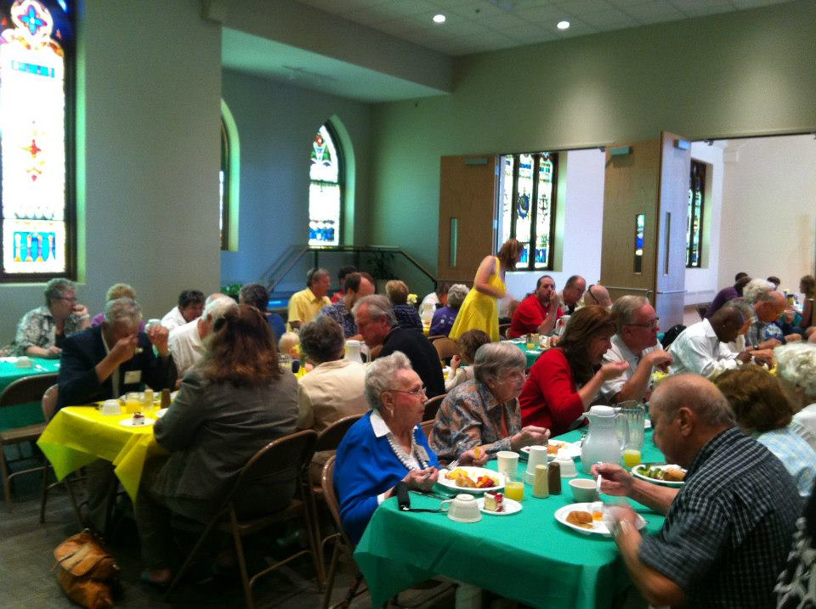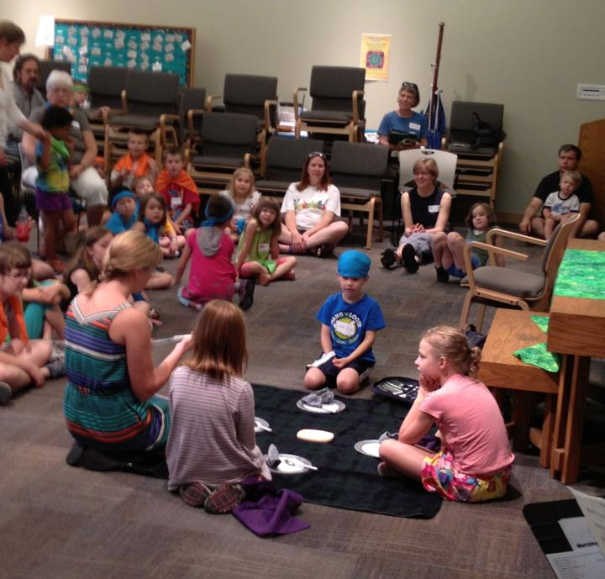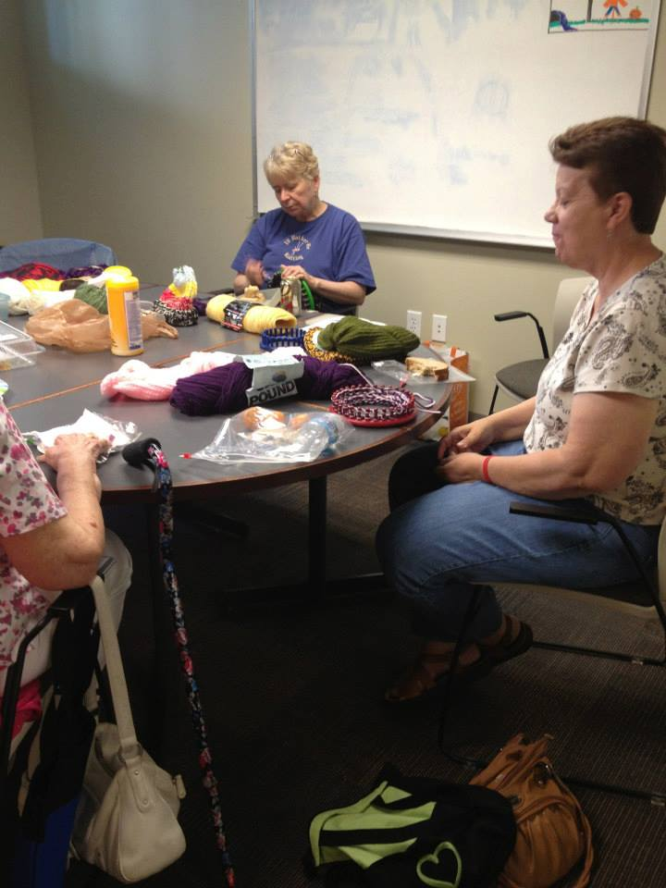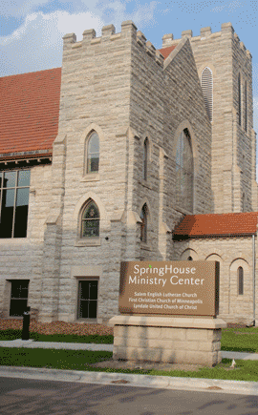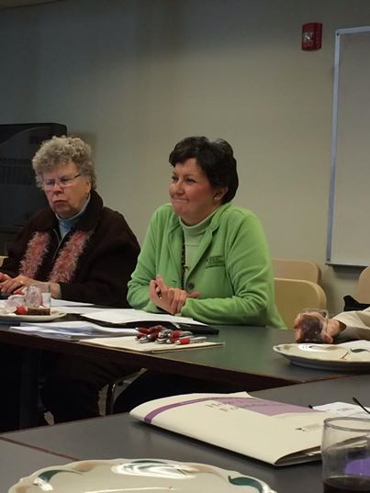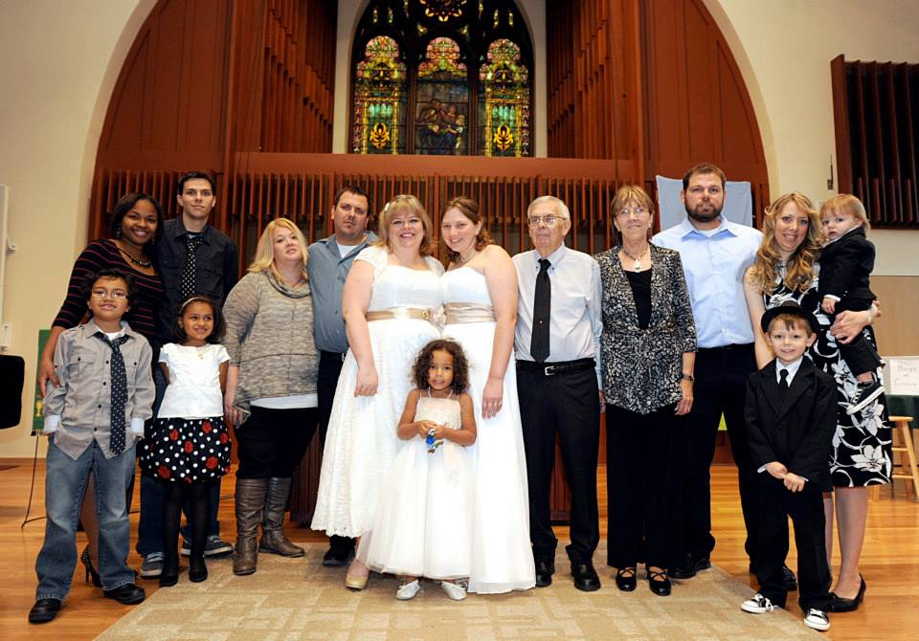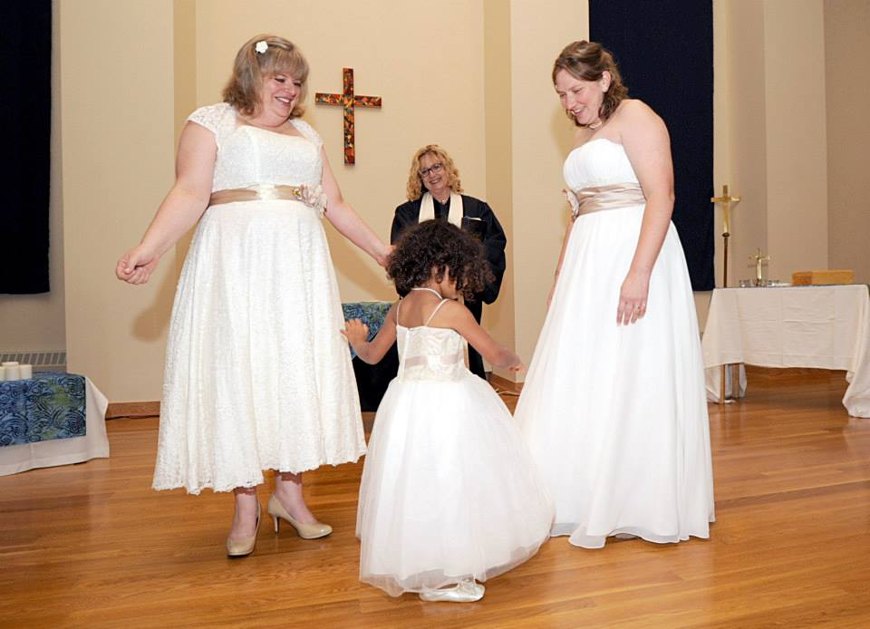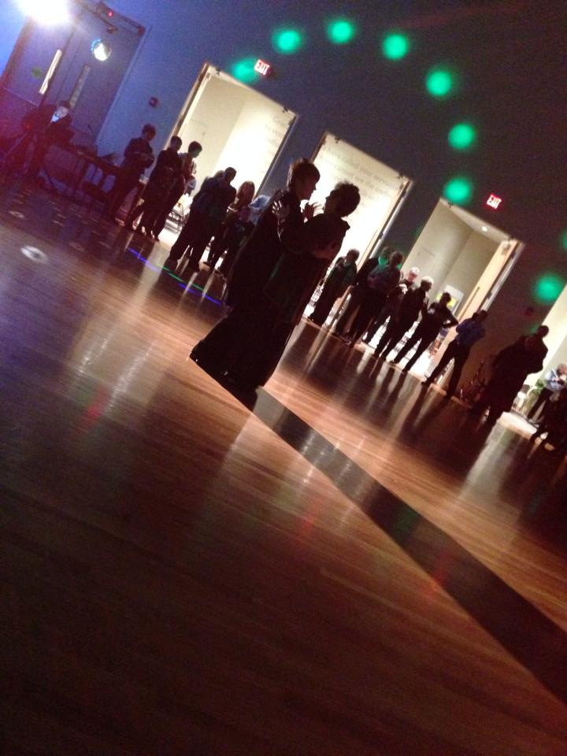

SpringHouse is a new way to be church in the 21st Century. It is a way in which congregations can become more environmentally and financially stable, allowing them to be free to do God’s mission in new ways.

SpringHouse is also a space where people can worship and learn about God. It is a place where the wider community can meet, renew, grow and work for wholeness.

SpringHouse is used by a variety of groups in the community – yoga classes, poetry classes, theaters, choral groups, LGBTQA teens, Narcotics Anonymous, dance groups, concerts …the list is practically infinite. Space is also available for a one-time meeting or an all-day retreat.

***Need a space for your club, group or meeting?***

***Call us!***

612-353-6292

www.springhousemc.org

610 W. 28th St.

Minneapolis, MN 55408

SpringHouse

Ministry Center

*Fees vary. Call to schedule a tour and to discuss fees.*

*612-353-6292*

Whether you are planning a wedding, your parents are celebrating an anniversary or your significant someone is hitting that milestone birthday, we have a place for your celebration!

We offer:

-Three sanctuaries, each with a different size and feel

-Reception area

-Professional-grade kitchen

-Dance floors

**Three sanctuaries, each with a different size and feel. Reception area with attached professional-grade kitchen. Dance floors.**

# Weddings…Anniversaries…

# Life Celebrations

### Let Us Help You Celebrate!